Notes to Help you with the Homework:

We always either *reject* or *fail to reject* the null hypothesis.

|  |  |  |
| --- | --- | --- |
|  | Other terminology | English |
| Reject the Null | Statistically significant  Differences between populations (population and sample)  The null is extremely unlikely | Basically we are saying that the probability of the null hypothesis (with the equal signs) is very low, so the research hypothesis is supported in this experiment. |
| Fail to Reject the Null | Not statistically significant  No difference between populations | We are saying that there is not enough evidence to reject the null – the null *may* be true OR the research *may* be likely and we just were not able to detect a difference (so the difference between groups is small and we just didn’t see it this time). |

Reading research results:

|  |  |  |
| --- | --- | --- |
|  | Stat-ese | English |
| These results were significant at the p<.05 level … | You are saying they are *significant* meaning that you *rejected* the null in step 5.  You would expect to find that there was *no difference* < 5% percent of the time (remember the p = the probability of you being wrong – the probability of the null hypothesis being true) | You are saying that there is a difference between the groups. |

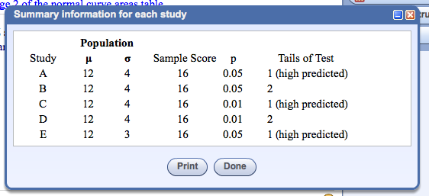

In this sort of table:

Mu (u) = population mean

Sigma (o) = population standard deviation

Sample score = X

p = the significance level for step 3

Tails of test = the better/worse/different selection for step 1 and 3

Steps:

1. Restate the problem as a research and null hypothesis
   1. Ask yourself – who was tested? (sample / population 1)
   2. Ask yourself – who are they being compared to? (population / population 2)
   3. Ask yourself – what do they expect to have happen? (better / worse / different)
2. List the comparison distribution
   1. What table am I using? (z for this test!)
   2. What information do I need to complete step 4?
3. List the cut off score
   1. Use the significance level given, as well as what you selected in step 1
4. Figure the sample score
   1. Using step 2, what did the person score on the comparison distribution?
5. Decide if you want to reject the null.